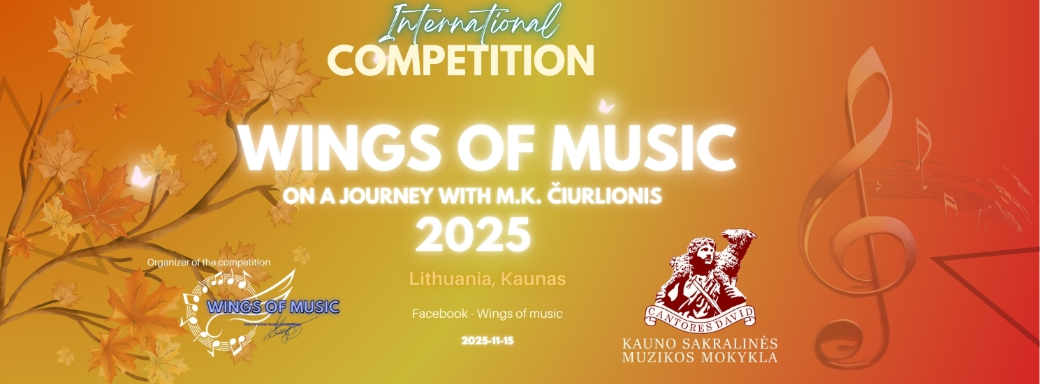

VI INTERNATIONAL COMPETITION
FOR INSTRUMENTALISTS AND VOCALISTS.
"Wings of Music: On a Journey with M. K. Čiurlionis 2025"
REFERENCES
GENERAL PART

The Regulations of the VI INTERNATIONAL COMPETITION OF INSTRUMENTALISTS - VOCALISTS "Wings of Music: On a Journey with M. K. Čiurlionis 2025" regulate the requirements for the participants, the organisation of the competition and the procedure of awarding prizes.

1. The Competition is organised in a CONTACT MODE.
1.1 Competition place – Lithuania, Kaunas, Kaunas School Of Sacred Music,
M. Valančiaus str. 8

2. The Competition is organised by Marija Teresė Jakelytė and Kaunas School of Sacred Music.

3. The aim of this competition is to reveal the creativity, artistic individuality and mastery of performance, creativity, aesthetic taste of the students, to establish creative contacts, to promote creative cooperation between students of Lithuanian and foreign music schools and their teachers, and to promote the dissemination of professional experience.

4. PARTICIPANTS
The competition is open to soloists, duets, trios, and ensembles up to 8 person.
Performers are divided into groups:
- Folk/national string instruments.
- Woodwind and brass instruments.
- Piano, Organ
- Strings (guitar, violin, harp, cello)
- Vocals (classical, jazz, pop, folk) with instrumental accompaniments or accapella only (phonograms not used)
by submitting the entry form, you confirm that you are aware of and agree to the terms and conditions of the competition.
5. The contestants are divided into groups according to category and age group:
- A - up to 6 years
- B - 7 - 9 years;
- C -10-12years;
- D - 13-15years;
- E - 16-19 years;
- F- 20+
the instrumental ensemble is assigned to an age group according to the average age of the ensemble members.
TIMING OF THE COMPETITION
6. 2025 15 November
IV. REGISTRATION OF PARTICIPANTS
7. Participants must fill in the following online registration form to register:
Vocalists Form:
https://forms.gle/3FmEFepXGWPnMqT79
For instrumentalists:
https://forms.gle/MSR6zYiYwHBqExUQ6

For Piano, Organ and Accordion

https://forms.gle/HC2B6JXwmvTCWbVv7

9. Applications are accepted until 1 November 2025.
ATTENTION! NUMBER OF PARTICIPANTS IS LIMITED
V. ENTRY FEE
11. Entry Fee:
11.1. Soloist (1 person) - 35 eur
11.2. Duet (1 person) - 30 eur.
11.3. Ensemble mini 3-5 (1 person) - 25 eur
11.4 Ensemble 4-8 (1 person) – 20 eur.
12. The entry fee must be paid at the time of registration and the bank payment document must be attached when filling in the online registration form.
If a performer participates in more than one category, the fee is payable for each category.

14. Requisites for payment:
Marija Teresė Jakelytė
Account: LT34 3250 0334 9052 3940
BIC / Swift - REVOLT21
Revolut Bank UAB
Konstitucijos ave. 21B, 08130, Vilnius, Lithuania
In the payment specify - Wings of music LIVE, participant's name and surname
VI. COMPETITION REPERTOIRE
15. Each participant (soloist, duo, trio, ensemble) performs 1 (one) piece of his/her choice. The duration of the piece is up to 4:00 minutes. Category F - up to 10 minutes
16. The competition is open to all genres of instrumental and vocal music. Participants may perform songs/compositions by Lithuanian and foreign authors as well as their own compositions.
17. The contestant must perform without a phonogram. Soloists shall perform the piece from the memory. Instrumental ensembles may play from sheet music.
VII. EVALUATION OF PARTICIPANTS
18. The jury of the Competition is composed of an international panel of competent professional musicians.
19. The performances of all age groups shall be evaluated with 1st - 3rd places and diplomas of 1-3 degrees in each group and category. All participants, their teachers and concertmasters are awarded letters of appreciation.
20. GRAND PRIX Prizes are awarded according to the highest scores awarded by the jury.
In the absence of worthy candidates, the GRAND PRIX prize and other prizes may be withheld. In the event of several Contestants scoring the same number of points, the Chairman of the Jury has an additional vote. The decision of the Jury is final and not subject to dispute.

20.1 Special Award:

The special award “On a journey with M.K. Čiurlionis” will be granted. Any participant who performs a work by M.K. Čiurlionis is eligible for this award. However, the competition program is freely chosen, and performing a work by M.K. Čiurlionis is not mandatory.
VIII. EVALUATION CRITERIA
21. Musicality, technique of the instrument.
22. Arrangement, interpretation of the work performed, originality, artistry.
22. Intonation and voice technique.
23. Aesthetics of the performer(s), stage image.
24. If you have any questions, please contact: Konkursas.muzikos.sparnais@gmail.com



Competition Organising Team :
Marija Teresė Jakelytė (singer of Lithuania Kaunas State Choir, founder and director of the choir "Humili")- founder, author and moderator of the idea, Organizer.
Kaunas School of Sacred Music, Director Priest Vilius Sikorskas - Organizers
Sister Pija Kristina Metrikytė ( Head Teacher of Kaunas Sacred Music School) - president of the jury, Coordinator, Moderator, Author of the idea
Aurelija Helmienė, Benita Mincevičiūtė (Administration of Kaunas Sacred Music School) - curators of the competition

