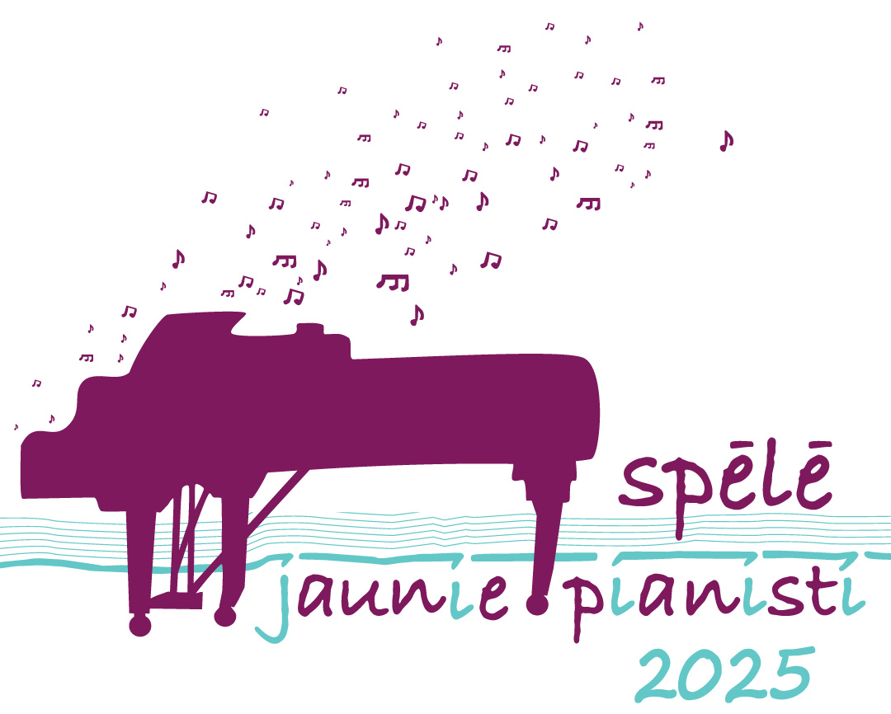

YOUNG PIANISTS PLAY!
7th International Piano Competition for Young Pianists

Regulation
Riga Pardaugava School of Music and Art organizes the 7th International Piano Competition for Young Pianists – in Riga, on December 5th, 2025.
Goals and Tasks of the Competition
- Promote young musicians’ interest in learning to play the piano;
- Discover and support young performing artists;
- Improve the growth of young musicians’ professional skills;
- Encourage the exchange of experience between the teachers and students of Latvian and foreign music schools.
Competition Time and Place
Competition will be held on December 5th, 2025, at 10am. The venue is The Big Hall of Riga Pardaugava School of Music and Art / Riga, Graudu Street 59.

Competition Terms
The competition is open to young pianists aged 16 and under.
Participants are divided into four groups:
Group A: | 7 – 8 years old (incl.) | The threshold date for determining  the age of participants December 5, 2025
Group B: | 9 – 10 years old (incl.)
Group C: | 11– 13 years old (incl.)
Group D: | 14 – 16 years old (incl.)

Participants Must Perform
- One freely chosen composition written till 18th century (including);
- One freely chosen composition written from the 19th to the 21st century;
- One or more compositions from the country participant represents.
The compositions included in the program must be performed by memory (no sheet music).
Time for performance
- Group A – up to 5 minutes;
- Group B – up to 8 minutes;
- Group C – up to 12 minutes;
- Group D – up to 15 minutes.
Application Process
Applications must be submitted electronically by November 7, 2025 via the following link:
https://ej.uz/RPMMSjauniepianisti2025
The performance schedule for each group will be confirmed after the application deadline.
Participant registration on the day of the competition begins at 9:00 am.
Riga Pardaugava School of Music and Art provides rehearsal space on December 4th,
which must be reserved in advance by phone: +371 29744571 (coordinator: Deizija Eičina).
Participants’ registration for the competition takes place on the day of competition, starting from 9:00 am.
Participation Fee
The participation fee is EUR 40,00 / per participant and must be paid by November 21, 2025 via bank transfer to the following account:
Rīgas pilsētas pašvaldība
Rātslaukums 1, Rīga, LV-1050
NMR kods: 90011524360
PVN reģ. Nr. LV90011524360
Luminor Bank AS Latvijas filiāle
SWIFT kods: RIKOLV2X
Konta numurs: LV72RIKO0021000916200
Saņēmējs:
IKSD iestāde: IKSD Rīgas Pārdaugavas Mūzikas un mākslas skola
Graudu iela 59, Rīga, LV-1058
In the payment order clearly indicate the name, surname and the aim of the payment – “Participation in the competition”.
During registration on the day of the competition, participants must present:
- Proof of payment.
Cancellations are accepted until November 29, 2025.
For cancellations received after this date, the participation fee will not be refunded.
Program changes will be accepted until November 29, 2025.
Competition Procedure
Competition is open; all the people interested in the competition are allowed to listen.
Competition has one stage.
Participants perform in groups starting from the youngest group and in the alphabetical order. Information on the competition schedule will be published in the homepage www.pmms.lv and sent by e-mail.
Evaluation and Awards
Participants are evaluated by the Jury accepted by the director of Riga Pardaugava School of Music and Art. The Jury is lead by the Head of the Jury.
The Jury will award the winners from the 1st to 3rd place in each group. Participants are awarded with diplomas and prizes. The Jury grants places using its own judgment. The teacher will receive the certificates.
The jury may also award a Special Prize for the best interpretation of a piece by a composer from the participant’s country in each group.
Each participant’s teacher will receive a certificate of professional development (6 hours).
Participants of the competition are evaluated in the system of 25 points using the following criteria:
- The adequacy of the repertoire to the rules of the competition;
- The brightness of the composition’s character;
- The adequacy of the composition’s complexity to the age group;
- The level of technical performance;
- The culture of performance.

The decision of the Jury is final and is not arguable.

Protection of Participants’ Personal Data
- Participants may be photographed or filmed. The resulting images and audiovisual materials may be published for the purpose of promoting children's and youth artistic activities and preserving cultural heritage, in the public interest.
- The participant’s teacher must inform the legal guardian of a minor participant that the participant may be recorded (photo, audio, or video) and that their personal data may be processed.

Competition Coordinator:
Deizija Eičina, piano teacher
Riga Pardaugava School of Music and Art
Phone: +371 29744571
Email: pmms@riga.lv

