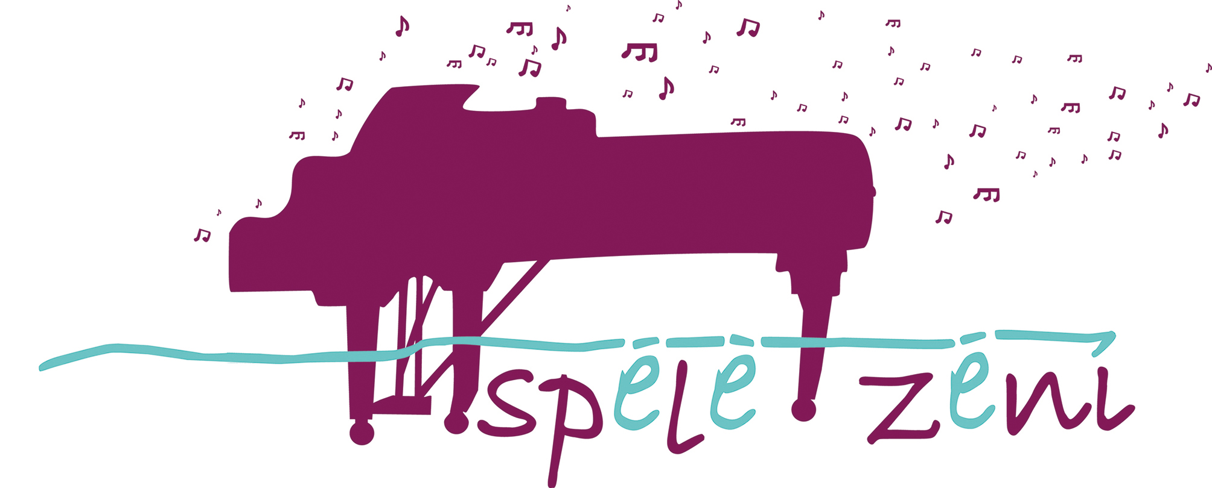

BOYS PLAY!
6th International Piano Competition for Pianists – Boys
Regulation
Pardaugavas Music and Art School in cooperation with Latvian Piano Teachers’ Association organizes the 6th International Competition for boys – music schools’ students of piano program – in Riga, December 9, 2023.
Goals and Tasks of the Competition
- Promote boys’ interest in learning the piano
- Discover and support young performers
- Improve the growth of young musicians’ professional skills
- Encourage the exchange of experience between the teachers and students of Latvian and foreign music schools
Competition Time and Place
Competition will be held on December 9, 2023, at 10am. The venue is The Big Hall of Pardaugavas Music and Art School, Riga, Graudu Street 59.
Competition Terms
Participants of the competition are boys - music schools’ students of piano program - divided in four age groups:
- Group A: 6 – 8 years (including);
- Group B: 9 – 10 years (including);
- Group C: 11 – 13 years (including);
- Group D: 14 – 16 years (including).
No more than three participants from each music school can participate in each age group. The date for defining the participants’ age is December 9, 2023 (e.g. if participant is 7 on December 7th, then he must be in Group A (6 – 8 years)).

Participants Must Perform
- Freely chosen composition written till 18th century (including);
- Freely chosen (but of a different character) composition written in 19th, 20th or 21st century;
- Composition from the country participant represents.

The compositions included in the program must be performed by memory (no sheet music).
Time for performance
- Group A - up to 7 minutes;
- Group B - up to 8 minutes;
- Group C - up to 10 minutes;
- Group D - up to 15 minutes.
Application Process
Applications can be submitted by e-mail pmms@riga.lv. Application form can be found in the attachment.
Application must be submitted by November 5st, 2023. The schedule of performances for each group will be adjusted after receiving applications.
Participants’ registration for the competition takes place on the day of competition, starting from 9:00 am.
Pardaugavas Music and Art School provides rehearsal space on December 8, which must be reserved in advance by phone: +371 26861736.
Participation Fee
Participation fee is 25 EUR for each contestant. The deadline for payment is November 5st, 2023. It must be paid by bank transfer. Following details:
Saņēmējs: IKSD
Pārdaugavas Mūzikas un mākslas skola,
Graudu iela 59, Rīga LV-1058,
RD iestādes kods: 21059
Rīgas pilsētas pašvaldība
Rātslaukums 1, Rīga, LV-1050
NMR kods: 90011524360
PVN reģ. Nr. LV90011524360
Luminor Bank AS Latvijas filiāle
SWIFT kods: RIKOLV2X
Konta numurs: LV72RIKO0021000916200
In the payment order clearly indicate the name, surname and the aim of the payment – participation in the competition.
The cancelations of participation are accepted till November 13th, 2023. Cancelations received after November 13th will not be accepted.
Changes in the program are accepted till November 13th, 2023.
Competition Procedure
Competition is open; all the people interested in the competition are allowed to listen.
Competition has one stage.
Participants perform in groups starting from the youngest group and in the alphabetical order. Information on the competition schedule will be published in the homepage www.pmms.lv and sent by e-mail.
Evaluation and Awards
Participants are evaluated by the Jury accepted by the director of Pardaugavas Music and Art School. The Jury is lead by the Head of the Jury.
The Jury will award the winners from the 1st to 3rd place in each group. Participants are awarded with diplomas end prizes. The Jury grants places using its own judgment. The teacher will receive the certificates.
Participants of the competition are evaluated in the system of 25 points using the following criteria:
- The adequacy of the repertoire to the rules of the competition;
- The brightness of the composition’s character;
- The adequacy of the composition’s complexity to the age group;
- The level of technical performance;
- The culture of performance.

The decision of the Jury is final and is not arguable.

Contact Information
The coordinator of the competition:
Valentīna Balunova
Pardaugavas Music and Art School
coordinator
Phone: Mobile +371 26861736
E-mail: pmms@riga.lv

